Mr. Uche Ezechi
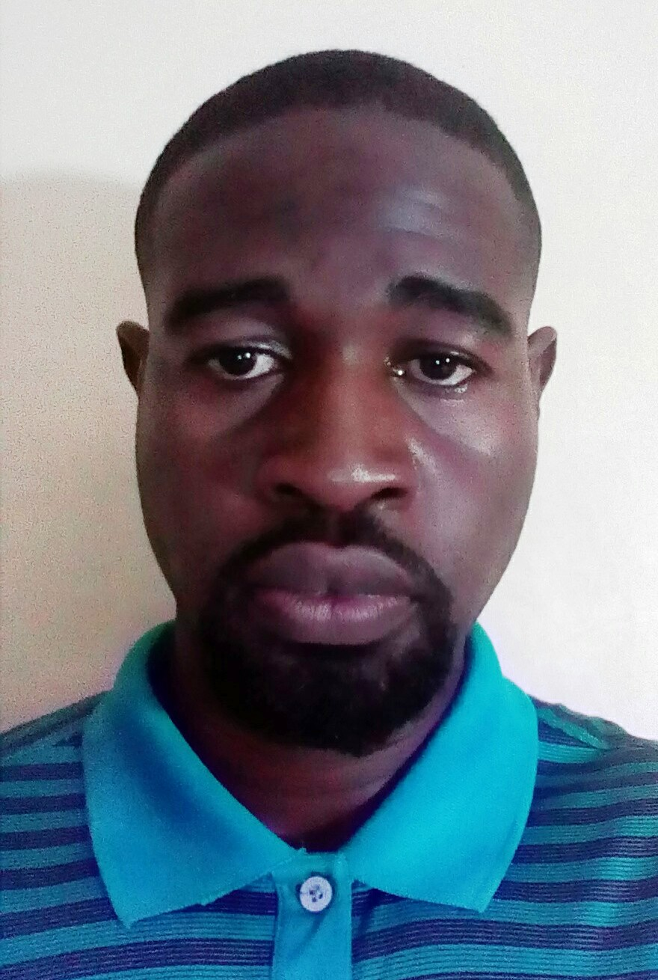

Department of Mechanical Engineering
University of Nigeria, Nsukka
Tel: 08162807945
E-mail: uche.ezechi@unn.edu.ng
PERSONAL:
Place and Date of Birth: KWALE, DELTA STATE; 20TH. DEC. 1989
Marital status: SINGLE
EDUCATION:
University of Maryland, Eastern Shore, MD, USA
B.Sc. Engineering, Mechanical - May, 2013
University of Delaware, Newark, DE, USA
Master of Engineering in Mechanical Engineering (MEME) - Dec, 2014
PROFESSIONAL SOCIETIES:
- American Society of Mechanical Engineers (ASME)
- Phi Kappa Phi Honor Society, USA
SCHOLARLY ACHIEVEMENTS:
- Graduated Summa Cum Laude (First Class) from my Undergraduate studies
- 2013 ASME Student Mechanism and Robot Design Competition Undergraduate Robot Division Third Place Award; Seatle, PO, USA - 2013
WORK EXPERIENCE:
Assistant Lecturer, (November, 2017 - till date)
Department of Mechanical Engineering
University of Nigeria, Nsukka
Managing Director, (May, 2016 - November, 2017)
Ottimo Engineering and Management Services
Asaba, Delta State
Technical Director (July 2016, - December, 2017)
ekumGURU Technologies Ltd (https://naijaguru.com.ng)
Asaba, Delta State
PUBLICATIONS AND RESEARCH:
Technical Reports
SAMPLE: Small Autonomous Monitoring Platform for Lakes and Estuaries - a Student Engineering Project - Jun 15, 2014. American Society of Engineering Educators (ASEE)
Conferences Presentations
National Emergency Management Agency (NEMA) - Flooding and Disaster Management
Presentation on "Waste-toWealth" - Asaba, Delta State; August, 2015

